6th Grade – OTIMMS – OKC Lesson

PARK PARTS!

GRADE LEVEL: 6th

DURATION OF LESSON: 2-3 class periods

OBJECTIVE:
- (OK PASS Standard 2.2) Convert, compare and order decimals (terminating and nonterminating), fractions and percents using a variety of methods.
- (OK PASS Standard 2.3) Estimate solutions to single and multi-step problems using whole numbers, decimals, fractions, and percents and assess whether solutions are reasonable (e.g., 7/8 + 8/9 is about 2, 0.9 + 0.3 is about 1).

MATERIALS LIST:
- Grid paper 24 x 20 (2 copies per pair)
- Pencil

- Eraser
- Ruler
- C2 Balance Act

- Table P-F
- Student Checklist
- Rubric

WARM-UP: Students will complete the C2 Balance Act for 48. Students should have experience with Balance Acts prior to this activity/lesson. As a class, have students share their values for given shapes and discuss how they came to their conclusions.

LESSON:

- LAUNCH: Ask students why people go to recreational parks. After students share, pair up students. Students will brainstorm a list of areas they would find in a park with a partner. The students will share their list with the class. The list is recorded on the board. At the same time, ask the students whether each area would be considered a small, medium, or large area. Answers will vary.

- EXPLORE:
- Once each pair has had an opportunity to share, the students will design/create their own recreational park. Each pair is given 2 copies of 24 x 20 grid paper and a copy of the Table P-Fractions is given to each student.
- Pass out the Student Checklist and explain to the students the guidelines for the Park Design.

    - Each area of the park must be less than one fourth of the total area.
    - Use fractions with at least 3 different denominators.
    - The design must include the following areas: water, restroom, food, sports field, and green space.
    - Use all space on grid paper.
    - Label park areas with a name and fractional part

- Students work in pairs to design their parks. Once students complete their design, they complete the Table P-Fractions. On the table, the students will list each fractional park areas included in their design and its fraction. Next, they must convert each fraction to a decimal and a percent. Then total each column. Lastly, students respond in writing to the following questions:

- What did you notice while adding the columns on your table together?
- In designing your park, did you find filling the whole grid easy or difficult? Explain.

- What did you discover about fractions within your park design?

- Which park areas included in your design were your favorites and how
did you decide on the size/fractional part for each?

- SUMMARY: Once students have completed their written responses, as a class, discuss the activity and the concepts learned regarding fractions. (i.e. Equivalent fractions, converting fractions to decimals to percents, interesting things in their designs.)

>>Extensions: Students could take final product and transfer park from grid paper to larger poster board and add details to illustrate the park. An advertisement could be made to make the community aware of the recreational park in the area and what it has to offer.

>>Modifications: For your challenged students, the grid may be reduced to a 12 x 12 grid and limit the number of mandatory areas to include to 3 instead of 5. For advanced students who finish quickly, provide opportunity to design another grid with different dimensions.

>>7th grade connection: Using scale and proportion as the objective, students may assign measurements to the areas. You could have the students use a variety of regular and irregular shapes. (7th grade PASS Standards 4.1)
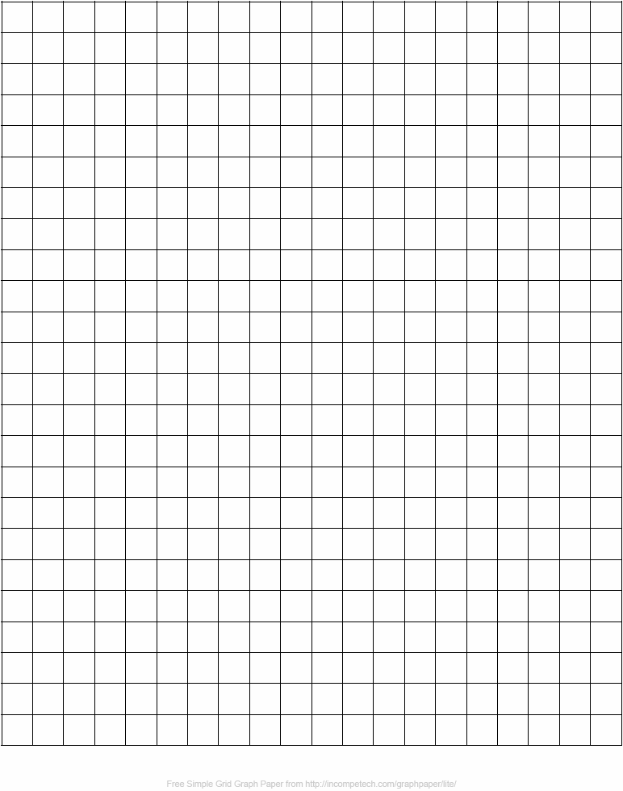

Partner Names _______________________________________________________

Table P-F

Name__________________________ Date__________________________

Park Fractions

Park Areas | Fraction | Decimal | Percent
Totals

Written Response:

STUDENT CHECKLIST
(Self-Assessment)

- GRID:

  - All space used on grid paper Yes_____ No_____
  - Park includes water area Yes_____ No_____
  - Park includes food area Yes_____ No_____
  - Park includes a sports field Yes_____ No_____
  - Park includes a restroom Yes_____ No_____
  - Park includes a green space Yes_____ No_____
  - Each park area is less than ¼ Yes_____ No_____
  - Each park area labeled with a name Yes_____ No_____
  - Each area labeled with a fraction in lowest terms Yes_____ No_____

- TABLE:

  - Each park area is listed Yes_____ No_____
  - Each fraction is converted to decimals Yes_____ No_____
  - Each decimal is converted to percents Yes_____ No_____
  - A total was found for each column Yes_____ No_____

- WRITTEN RESPONSE:

  - Written in complete sentences Yes_____ No_____
  - Explained park and table in my own words Yes_____ No_____
  - Explained findings from the table Yes_____ No_____
  - Shared your favorite areas and how you Yes_____ No_____
Decided on the fractional parts

RUBRIC

Scoring | 4 | 3 | 2 | 1
Grid | - All grid space used  - Design includes water, green, sports field, food, and restroom areas  - Park areas labeled: name and fractions  - Each park area is less than ¼ | - Some grid not used  - Most labels correct  - Includes 5 park areas  - Most fractions correct  - Fractions not put in lowest terms | - Some fraction labels incorrect or missing  - Labels missing  - Some grid not used
Table | - All parts of the table complete and accurate  - Fractions in lowest terms  - Totals found for columns: fraction, decimal, % | - All parts of the table complete and accurate  - Fractions might need to be put in lowest terms  - Totals found for columns: frac., dec., % | - Missing major component  - Errors converting fraction to decimal to percent | - Table missing  - Incorrect conversion: fraction to decimal to %
Written  Response | - Written in complete sentences  - Explained park and table  - Explained findings from table  - Shared favorite areas and decision for its fractional part | - Written in complete sentences  - Explained park and table  - Explained findings from table  - Shared favorite areas and decision for its fractional part | - Unclear communication  - Did not answer all summary points | - Unclear communication  - Did not answer all summary points

