Name _____________________________________ Date __________________

PopBots! Mission 10

This contest is a very exciting, single elimination battle between two opposing robots. But before you can change your robot into a PopBot and challenge another robot to a match, you must prove yourself worthy by a test of knowledge and imagination.

YOU NEED:

1 Norland Calculator Robot and 1 TI-83 or TI-84 Graphing Calculator
1 84-inch Data Cable and 1 Submini Coupler
Water Balloons and Driving Skills
Program: EXPLORE2

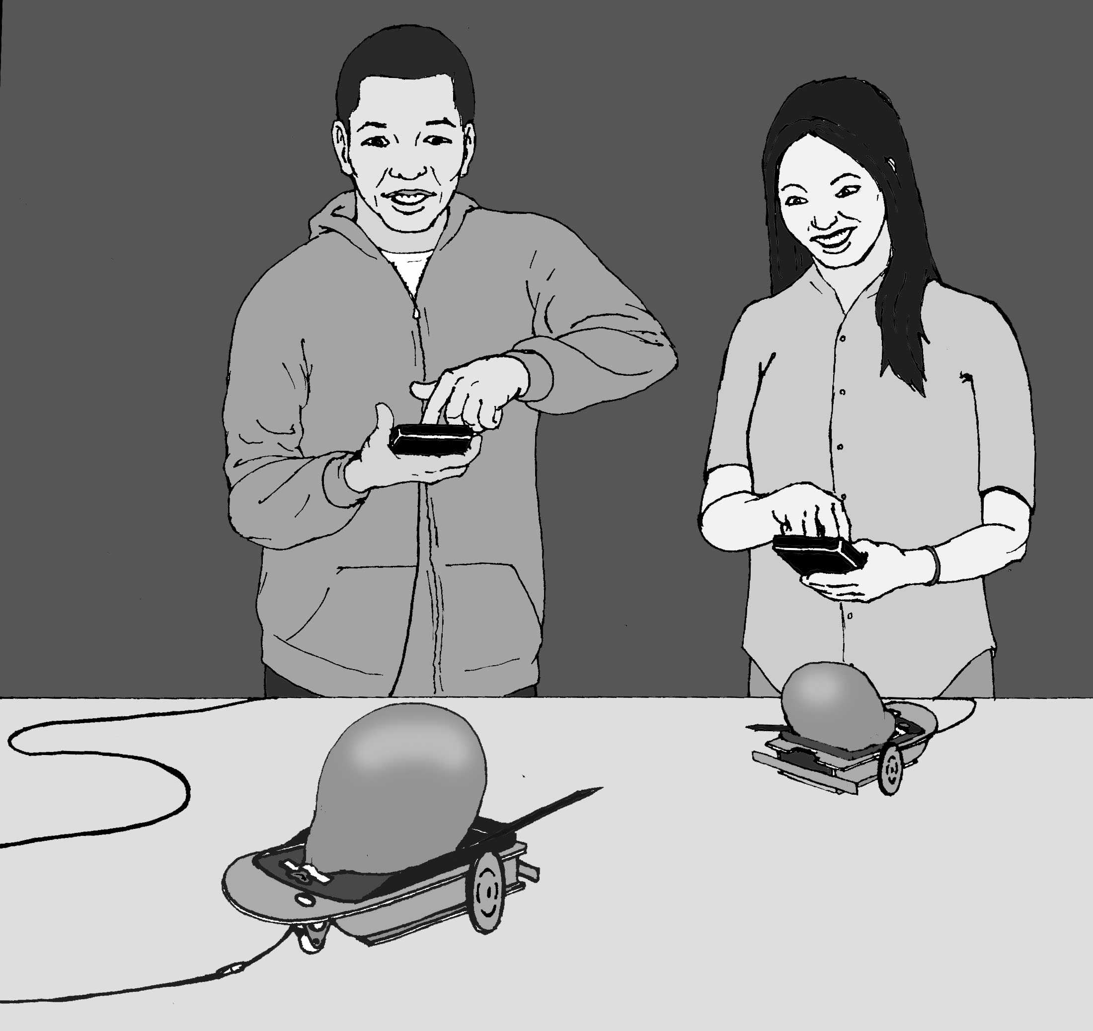
ARE YOU WORTHY?
(Show all work on a separate sheet. Diagrams will help you visualize and solve some problems.)

- A robot travels at the constant speed of 17.45 cm/second. How many seconds will it take this robot to travel 205 centimeter? (Round your answer to the second decimal place.)

- A robot draws a circle that is 47.1 inches around. What is the diameter of this circle in inches? (Use pi = 3.14.)

- On the planet Libathonkey they play ROBOT SHUFFLEBOARD, which is similar to shuffleboard here on Earth, except you use a robot and points are received when the robot stops on a numbered section of a circular court. The court has a diameter of 2 meters. What is its area? (Use pi = 3.14.)

- This same circular ROBOT SHUFFLEBOARD court is divided equally into eighths. One section is 10 points, two are 8 points, two are 7 points, two are 6 points, and one is 10 points off. If a robot randomly lands on the court once, what are the chances of getting more than 7 points?

- If you were trying to pop a balloon on another robot only using a pencil. Where would you place that pencil on your robot and at what angle? In the EXPLORE2 program the [5] key is open for a free movement command. What command would best help you pop the balloon on an opposing robot?

- Suppose in the year 2008 a recycling machine is invented that completely changes matter into energy. How much energy would be produced by putting a 2 kilograms math textbook into the machine? Give your answer in joules and in scientific notation. (Use 300,000,000 meters/second as the speed of light.)

- The entrance to a cave has collapsed and your friend is trapped inside. He needs food, medical supplies, and light, but there is only a narrow opening that winds between granite boulders. Program your robot to carry a lifeline to your friend. It needs to travel 2.25 seconds north, 2.50 seconds northeast, and then back due north 5 seconds to reach your friend. Show your teacher your answer.

- Imagine your robot in the middle of an open floor made of square vinyl floor tiles, one foot on a side. The robot travels 5 squares north, 12 square east. In feet, how long is the shortest distance back to the start?

- Describe the movement of the TI-83/84 graph of each equation when it is changed as shown:

- Y=2X -> Y=2X+5

- Y=abs (X) -> Y=abs (X+3)

- Y=X² -> Y=(X-3)²

- Some students in my class think that the reason we've had trouble with spacecrafts and robots on or near Mars is that the Martians don't want us there. If there were Martians, what characteristics would they have? Why haven't we detected them?

INSTRUCTIONS for POPBOTS:

Use the EXPLORE2 program from the last mission. You may want to adjust your robot's response to the [5] key. This is an open keystroke to put in any defensive or offensive movement you feel necessary.

Use the 84-inch data cable with your robot. Practice your driving and maneuvering skills to prepare for battle. When your turn for a match comes, your teacher will provide you with an air-inflated water balloon to attach to your robot. Balloons must be securely attached (large end forward) with tape to the calculator cover on top of the robot.

You are allowed either one mechanical or regular pencil to use as a balloon lance. Attach the pencil in the best position to pop the balloon on an opposing robot. Use a round table or designate a round contest ring. If a robot starts to fall off the table or has two wheels (back roller included) out of the ring, it is disqualified and the other robot automatically wins. Otherwise, the first robot to pop its opponent's balloon WINS the match and remains in the ring until defeated. (Current record: Stephen-6 consecutive wins.)

If a balloon comes loose during a match, the contest is stopped. The balloon is reattached, and then the match is restarted.

Let the games begin!

Teacher Notes

PopBots! Mission 10

ACTIVITY NOTES:

Test Questions:

- Time=11.75 seconds (rounded): D=rt, 205=17.45t, solve for t.

- Diameter=15 inches: C=d, 47.1=3.14d, solve for d.

- Area=3.14 square meters: A=r², A=3.14(1²), solve for A.

- Probability=3/8: One 10 and two 8's out of eight possible choices or P(A)=n(A)/n(S), P(A)=3/8.

- Answers will vary: Open ended questions.

- Energy=1.8X10¹⁷ joules: E=mc², E=2(300,000,000²), solve for E.

- The program should look something like this:

PROGRAM:LIFELINE
:Send({122,225})

:Get(R)
:Send({120,21})
:Get(R)
:Send({122,250})

:Get(R)
:Send({102,21})
:Get(R)
:Send({122,500})

:Get(R)
:Stop

- Hypotenuse=13 feet: a²+b²=c², 5²+12²=c², solve for c.

- Questions:
- Moves straight-line graph five units up the y-axis.
- Moves an absolute value graph three unit to the left on the x-axis.
- Moves parabola three units to the right on the x-axis.

- Answers will vary: Open ended question. My students and I spent a whole period in class discussion on the topic.

PopBots is an exciting activity. My students loved it and it was a great way to finish the class. A small pump to inflate balloons is useful and the safety issue of sharp pencils needs to be addressed before the activity begins. Safety goggles should be worn by all involved.

