Name _____________________________________ Date __________________

Measure Mission 1

Your first mission, should you decide to take it (and you will), is to measure the width of the hallway outside your classroom using only a robot and a graphing device.

YOU NEED:

1 Norland Calculator Robot (Your wheels for this adventure)
1 TI-83 or TI-84 Graphing Calculator (Robot brains)
1 Meter Stick
Program: GO

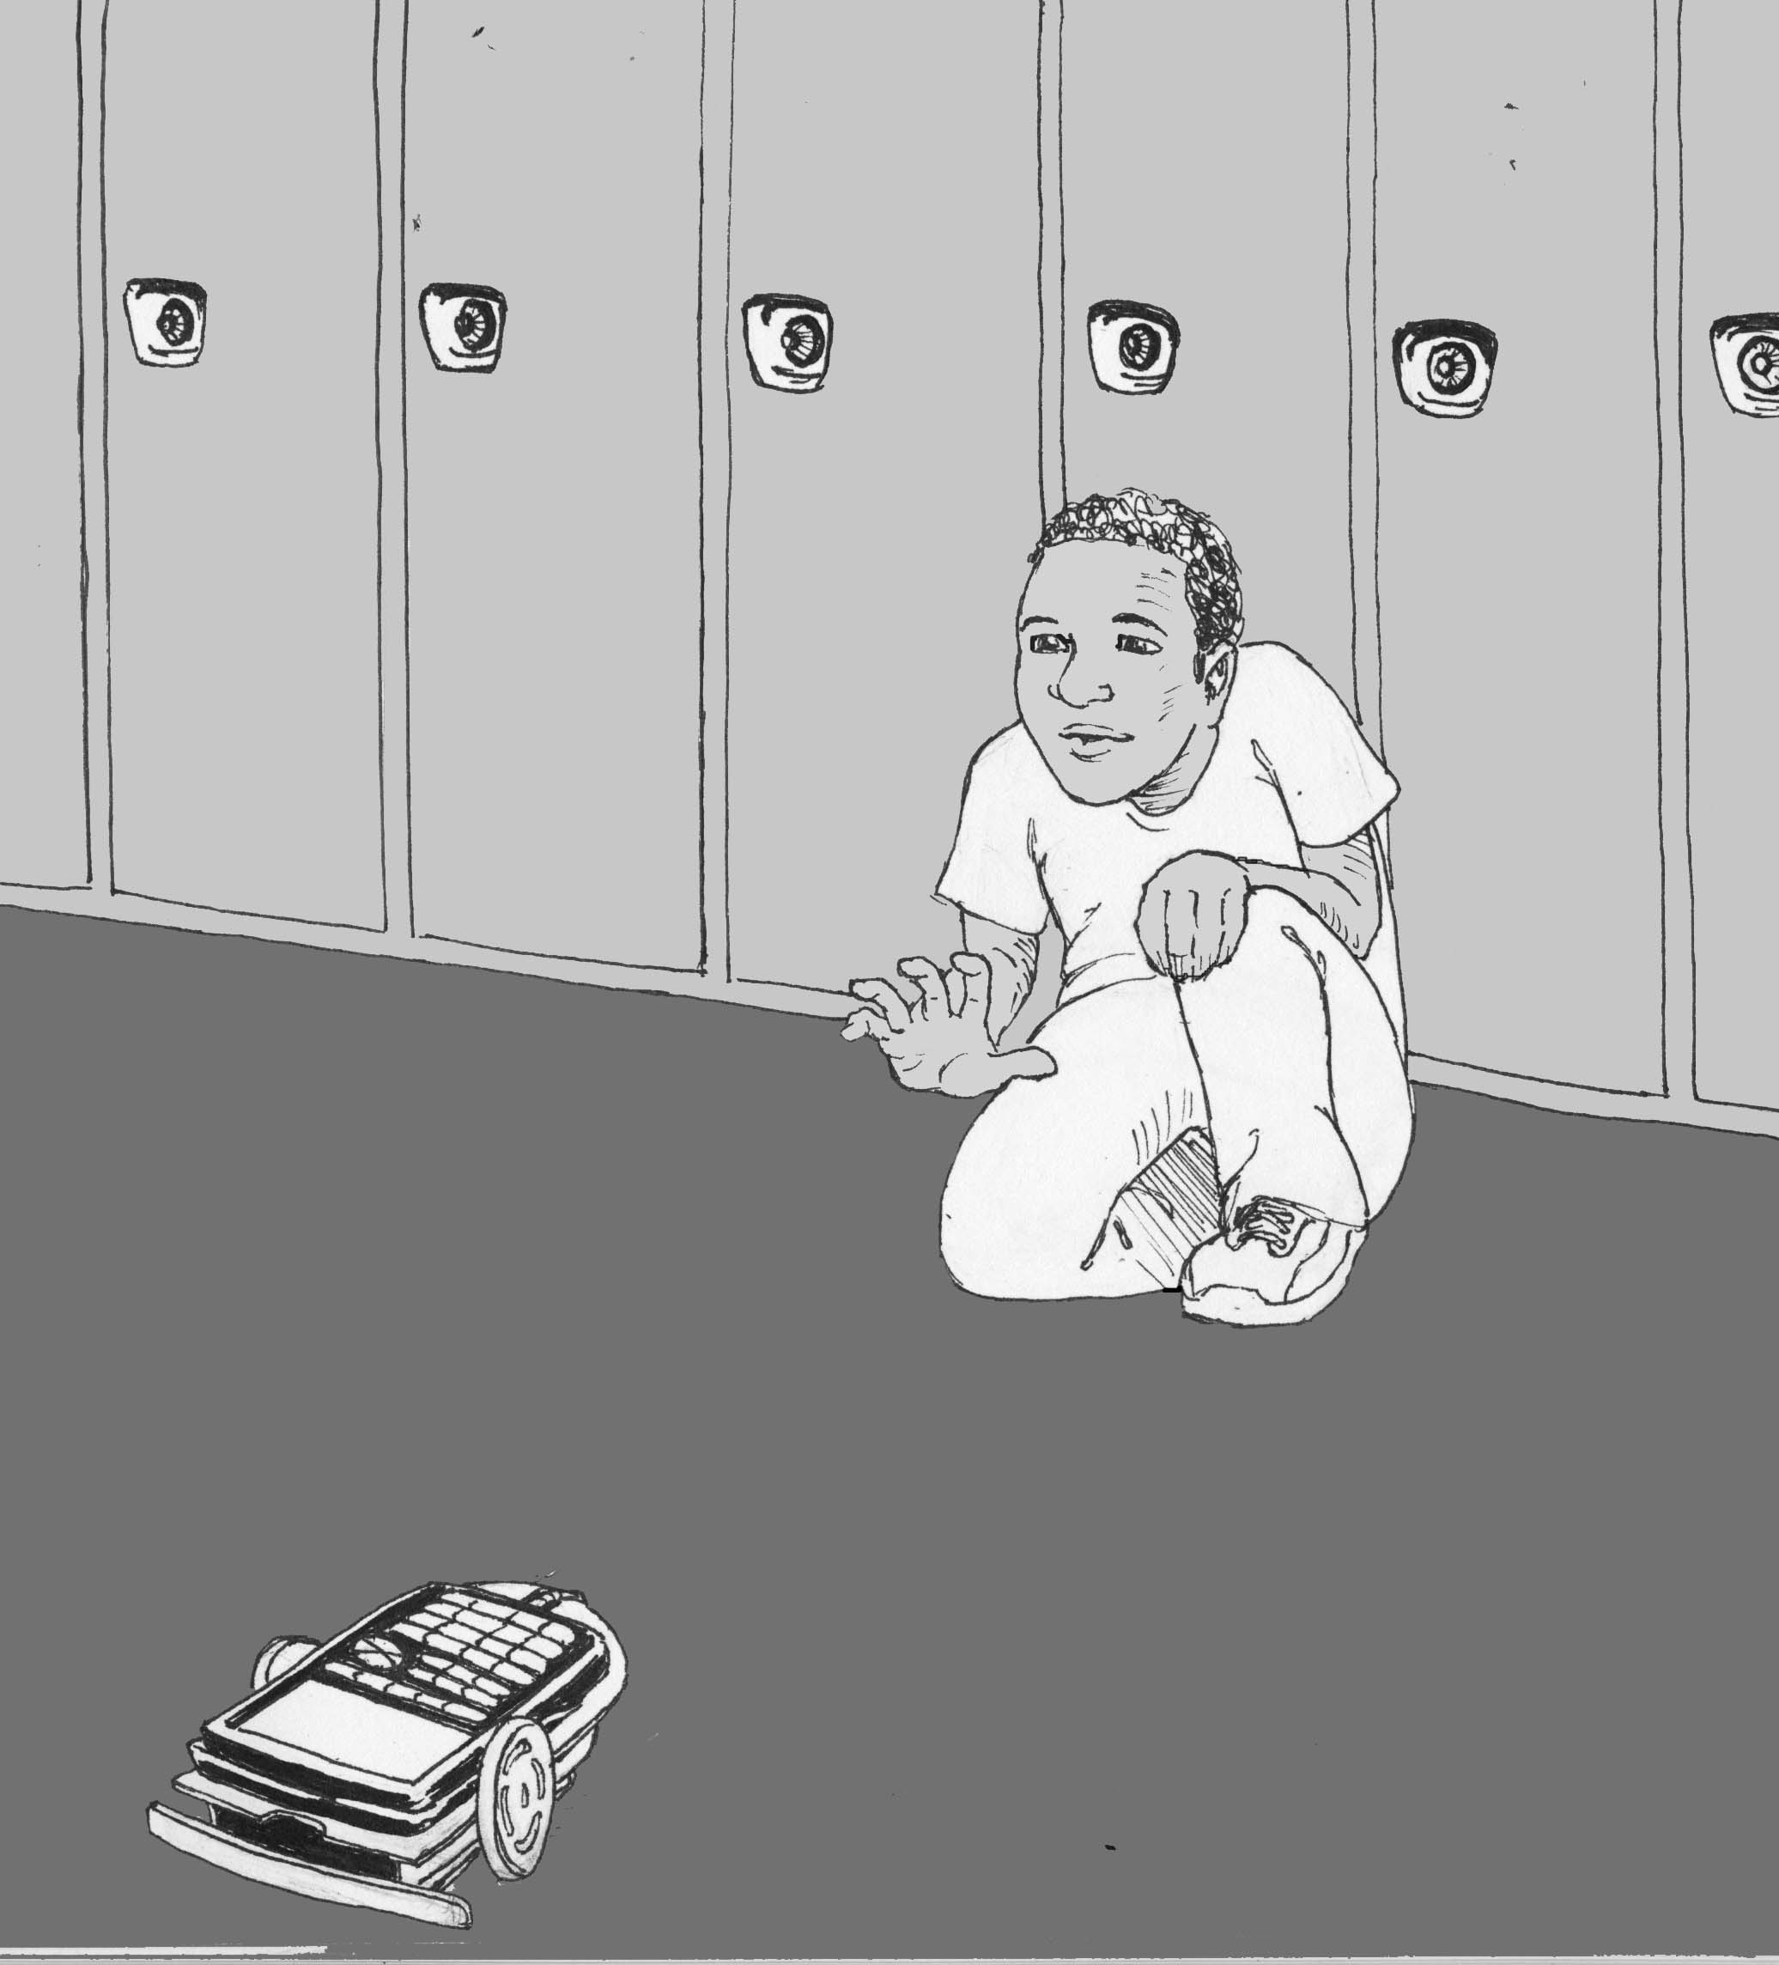

INSTRUCTIONS:

Write a simple program (see PROGRAMMING INSTRUCTIONS if needed) for your robot on a TI-83/TI-84 calculator named GO:

PROGRAM: GO
: Send ({222})
: Get (R)
: Disp R
: Stop

This will instruct the robot to move forward until its bumper runs into something. Attach your TI-83/TI-84 to the robot and run GO. You have fifteen minutes to experiment using the robot and a meter stick before you measure the hallway. Remember the meter stick cannot leave the classroom and the width of the hallway must be measured using the movement of the robot. Time will be displayed in centiseconds on the graphing calculator's screen after each run, i.e. 524=5.24 seconds. On the following page are tables to help you record your data. Decide ahead of time how to label the columns and rows.

Accuracy of Measurement Grading Scale:

Within 0 to ≤10 cm A
>10 to ≤20 cm B
>20 to ≤30 cm C

Off by more than 30 cm (or messing around): Long boring assignment in textbook
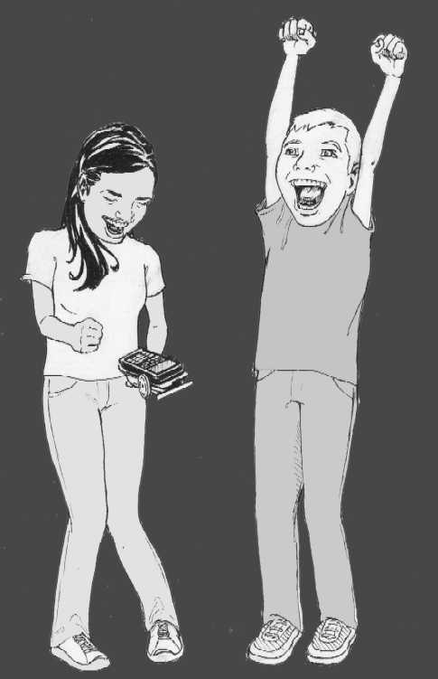

Who will be closest to the
actual measurement?

Mission Data:
Inside the classroom:

Trials
Total
Average

Outside the classroom:
(No meter sticks allowed)
Trials
Total
Average

RESULTS:

- What is your estimate of the width of the hallway in centimeters?

- What was the speed or rate of your robot?

- The bumper is at the front of the robot. How did you account for this in your measurement of the hallway?

- What calculations did you use to determine the width of the hallway?

EXTENSION:
(Answer on a separate sheet.)

Using the speed of the robot, determine your height in centimeters. Write your results with initials on the board. When the entire class has their measurements displayed, determine the mean, mode, median, and range for the data.

Convert your height to feet and inches. How tall are you?

Design an advanced robot program to automatically measure distance.

Measure Mission 1

PROGRAMMING INSTRUCTIONS:

Turn on TI graphing calculator. Press the PRGM button, then use the arrow to highlight "NEW". Press the ENTER button, then spell out GO by pressing the appropriate keys. Press the ENTER button and you're ready to enter the first command for the program.

Line 1: Press the PRGM button, then use the arrow to highlight "I/O". Use the arrow to scroll down to "B: Send (". Press the ENTER button. Press the 2nd button and then press { for an open brace. Type in 222. Close the braces and parentheses by pressing the 2nd button, the } button, and then the ) button. Press the ENTER button. The first line should appear as:
:Send ({222})

Line 2: Press the PRGM button, then use the arrow to highlight "I/O". Use the arrow to scroll down to "A: Get (". Press the ENTER button. Press the ALPHA button, then press R. Press ) then ENTER. The second line should appear as:
:Get (R)

Line 3: Press the PRGM button, then use the arrow to highlight "I/O". Use the arrow to scroll down to "3: Disp". Press the ENTER button. Press the ALPHA button, then press R. Press the ENTER button. The third line should appear as:
:Disp R

Line 4: Press the PRGM button and "CTL" will be highlighted. Use the arrow to scroll down to "F: Stop". Press the ENTER button. The fourth line should appear as:
:Stop

Press the 2nd button, then QUIT.

To run the program, attach the TI-83/TI-84 calculator to your robot and connect link cable. Make sure the robot and handheld are both switched on. Press the PRGM button and use the arrow to scroll down to ": GO". Press the ENTER button. Place the robot on the floor, then press the ENTER button again and the robot will move forward until the bumper hits something.
Teacher Notes

Measure Mission 1

ACTIVITY NOTES:

Measure the hallway yourself with a metric tape measure or meter stick. Students work well in pairs for this activity. If robots veer to one side or the other, adjust the rubber bands on the wheels or download the Calibrate Program from: http://www.smallrobot.com/school.htm.

Data tables are left partially blank for students to choose their own labels and methods. A more directed approach would be to label the first table across the top with TRIALS, 100 CENTIMETERS, 200 CENTIMETERS. Number of trials could be listed down the first column. TRIALS, TIME, and DISTANCE could be used in the second table with the first column again labeled with number of trials.

Students can be left to discover ways to solve this problem on their own or they can be given some review on proportions or the DERT formula (distance = rate X time or d=rt). After the initial use of the meter sticks, it's helpful to store them away to avoid other creative, but less mathematical solutions.

When measuring the hallway, the length of the robot (from the front bumper to the back) needs to be taken into account. This can be measured beforehand, calculated out in the hallway by running the robot the short distance of its own length, or sometimes an adjusted starting point can be used.

In the extension activity, one way to measure height is to have students lie on the floor with their feet against the wall and use the robots to measure how many seconds tall they are. Then use the DERT formula to convert to distance/height.

