Name _____________________________________ Date __________________

Turns and Mazes Mission 3

The third mission is to program your robot to navigate a maze, retrieve a secret package, and return to the original starting point. As always should your robot be discovered or captured, your teacher will disavow any knowledge of your mission. Good luck.

YOU NEED:

1 Norland Calculator Robot
1 TI-83 or TI-84 Graphing Calculator
Several Meter Sticks
Graph Paper
Program: MAZE

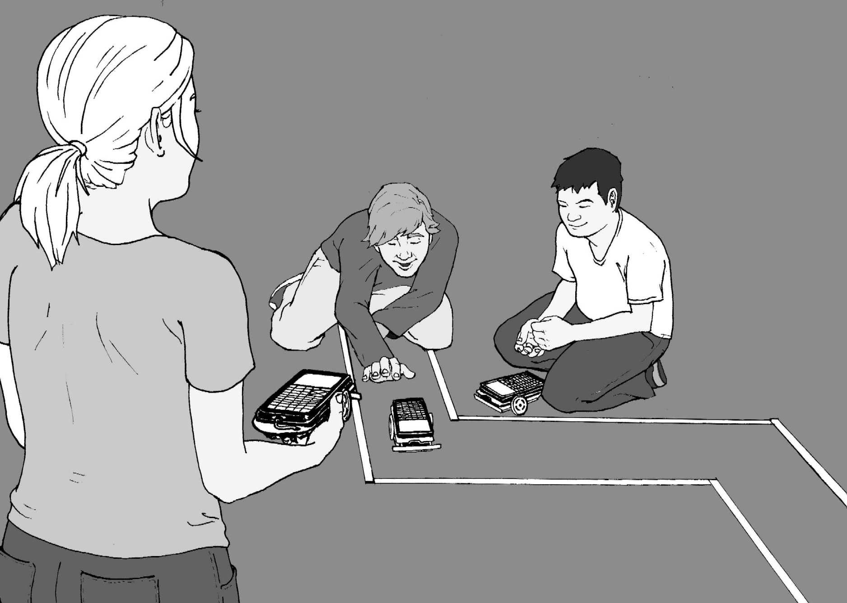

INSTRUCTIONS:

Discuss how many different ways you can program your robot to turn. Which ways might be best for navigating a maze? How can you make a 90º turn? Layout a practice maze with meter sticks on each side about one foot apart. Start with two straight runs with a right angle turn in between them. Create the new program MAZE (see PROGRAMMING INSTRUCTIONS if needed). When programming your robot, recall the following numbers used in a Send command. For example, Send ({ABC,xxx}):

A-Time or Bumper B-Left Wheel C-Right Wheel
1=timed movement only 0=backwards 0=backwards
2=move until bumper hits 1=no motion 1=no motion
3=time or until bumper hits 2=forwards 2=forwards

xxx is the number of seconds of run time in centiseconds.

For example: Send ({122,600})
Get (R) (Always needed to close a Send command.)

The robot will move forward for 6 seconds.

You'll need to know how fast your robot travels. For example, if your robot takes 5.27 seconds to travel the distance of one meter stick or 100 cm, it's traveling at approximately 18.98 cm per second (r=d/t or r=100/5.27).

When you've discovered how to make your robot rotate for a turn, you'll need to determine how many seconds the rotation must last for a 90 degree turn.

CHALLENGE:

The official test maze will have four straight runs and three turns. At the end of the maze there will be a secret message cube that must be recovered. Attach something to the robot so that the message cube can be retrieved.

The chart that follows can help you plan your strategy for completing the maze.

Maze Chart
Run 1  (In centimeters) | Time Needed  (In centiseconds) | Commands
Turn 1
(Left or Right)
Run 2
(In centimeters)
Turn 2
(Left or Right)
Run 3
(In centimeters)
Turn 3
(Left or Right)
Run 4
(In centimeters)

Grading Scale:

Robot retrieves message cube and returns it to start: A+
Robot retrieves message cube and spins in circle for joy: A
Robot makes it through, but misses message cube: B
Robot makes it half way through the maze: C

RESULTS:

- List five different environments where it might be too dangerous for humans to explore, but a robot could go and send back valuable information.

- Describe three situations where humans couldn't reach and you would need a small robot to explore.

- Have you seen the Fantastic Voyage? Could miniature robots be used to explore the human body. Draw a picture of miniature robot below and explain what devices it might have to explore the human body?

EXTENSION:

Place a small piece of tape labeled Point A on the floor. Place another piece of tape five feet (feet: primitive units of measure) away and label it Point B. Program your robot to get from Point A to Point B, but your journey must include one right angle (90º) turn at a point we'll call Point C. Measure the distances your robot travels before and after Point C. Below draw the right triangle ABC and label the distances between each point to the nearest whole foot.

1. What do you notice?

- If points A and B were 10 feet apart, how far would your robot have to travel before and after Point C, the right angle (90º) turn? Draw and label the new triangle formed.

- If Point A and B were 13 feet apart, what would be the shortest distance your robot would travel before making a 90º turn at Point C?
Turns and Mazes Mission 3

PROGRAMMING INSTRUCTIONS:

Turn on TI graphing handheld. Press the [PRGM] and arrow to highlight NEW. Press [ENTER], then spell out MAZE by pressing the appropriate keys. Press the [ENTER] button and you're ready to enter the first command for the program.

Line 1: Press [PRGM], then use arrow to highlight I/O. Use arrow to scroll down to B: Send ( and press [ENTER]. Press the [2ND] button and then press { (the ( key) for an open brace. Type in 122,600. Close the braces and parentheses by pressing [2ND], }, and then ). Press [ENTER]. The first line should appear as:
:Send({122,600})
(Line 2: Is blank)

Line 3: Press [PRGM], then arrow to highlight I/O. Use the arrow to scroll down to A: Get (, and press [ENTER]. Press [ALPHA], then type R. Press ) then [ENTER]. The third line should appear as:
:Get(R)

Line 4: Press [PRGM], then use arrow to highlight I/O. Use arrow to scroll down to B: Send ( and press [ENTER]. Press the [2ND] button and then press { (the ( key) for an open brace. Type in 120,42. Close the braces and parentheses by pressing [2ND], }, and then ). Press [ENTER]. The fourth line should appear as:
:Send({120,42})

Line 5: Press [PRGM], then arrow to highlight I/O. Use the arrow to scroll down to A: Get (, and press [ENTER]. Press [ALPHA], then type R. Press ) then [ENTER]. The fifth line should appear as:
:Get(R)

Line 6: Press [PRGM], then use arrow to highlight I/O. Use arrow to scroll down to B: Send ( and press [ENTER]. Press the [2ND] button and then press { (the ( key) for an open brace. Type in 122,600. Close the braces and parentheses by pressing [2ND], }, and then ). Press [ENTER]. The sixth line should appear as:
:Send({122,600})
(Line 7: Is blank)

Line 8: Press [PRGM], then arrow to highlight I/O. Use the arrow to scroll down to A: Get (, and press [ENTER]. Press [ALPHA], then type R. Press ) then [ENTER]. The eighth line should appear as:
:Get(R)

Adjust command times as necessary. Add forward motion and turns as needed. A sample left turn is, :Send({102,42}).
Teacher Notes

Turns and Mazes Mission 3

ACTIVITY NOTES:

There are several ways to make the robot turn; one wheel stopped and the other moving forward or backward; one wheel moving forward and the other moving backwards. A sample right turn would be: Send ({120,42}) followed by Get (R). Hopefully by now most students are becoming comfortable programming robot movements on the calculator. However, if needed, a starter program that includes two straight runs with a right angle turn in between can be found in the PROGRAMMING INSTRUCTIONS. An alternative programming method is to use two programs and the recall command.

For example, first have students experiment with programming turns in their GO program from Mission 1, then have them program a straight run and a right turn. They can then create the new program MAZE and repeatedly recall sets of instructions from the GO program as follows.

From the new MAZE program press the yellow [2nd ] key, then RCL (the STO-> key). Press PRGM, then scroll over to EXEC and select GO. Press [ENTER] twice and the instructions from GO will be added to MAZE. Edit commands and times as necessary. This process can be repeated as many times as needed.

Sometimes just getting through the maze is challenging enough. I used meter sticks about a foot apart and included left and right turns. A straight running robot is helpful. Rubber bands can be added to the robot's wheels to adjust for veering. Place a paper cube (templates available on Internet) with a message inside at the end. A rolled piece of tape on the robot's bumper works for "picking up" the cube or adhesive Velcro dots can be used.

The extension activity provides an opportunity to discuss right triangles and the Pythagorean Theorem. Pythagorean triples involved in the activity are (3,4,5), (6,8,10), and (5,12,13). A linoleum floor composed of one foot square tiles is helpful to visualize the right triangles formed by the robots' movements.

Another interesting extension is to have students use their maze programming skills and have their robots duplicate the first iteration of the Jurassic Park fractal. See: http://math.rice.edu/~lanius/frac/real.html.

