Name _____________________________________ Date __________________

Circles Mission 4

Your fourth mission is to draw circles using the robot. Sounds simple enough, but you'll need to draw three different diameter circles using three different wheel motions. Good luck.

YOU NEED:

1 Norland Calculator Robot and 1 TI-83 or TI-84 Graphing Calculator
1 Clothes Peg or Norland Research Pen Holder (www.smallrobot.com)
1 Marker
1 Meter Stick
String
Drawing Paper 18"X24"
Program: CIRCLE

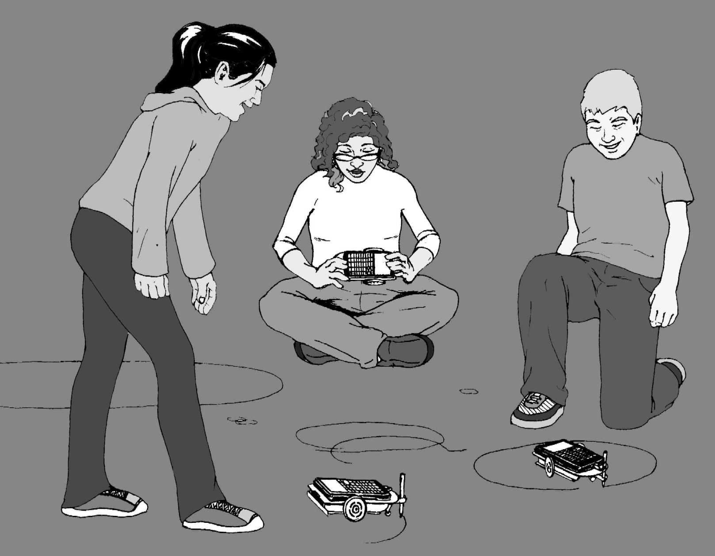
INSTRUCTIONS:

Write a simple program for the robot on your TI-83/84 named CIRCLE (see PROGRAMMING INSTRUCTIONS on page 6 if needed):

PROGRAM:CIRCLE
:Send({120,200})
:Get(R)
:Disp R
:Stop

This program will instruct the robot to spin in a circle for a given amount of time. Attach a clothes peg or pen holder at the underside, rear of the robot with tape or Velcro. Place your robot with wheels centered at the middle of a sheet of 18"X24" drawing paper. Use the clothes peg to hold and position a marker on to the paper. Run the CIRCLE program and draw a circle. Adjust the time (i.e. 200) in the "Send" command as needed to draw a complete circle.

Save your best circle drawing for the next mission. Cut a piece of string the same length as the diameter of your circle. Trace around the circle with your length of string. Be as accurate as possible.

- About how many string lengths or diameters does it take to go around the circle?

You should have a small gap in between the initial starting point and the end of the last string length. Measure the distance of the gap and divide it by the length of the diameter.

- Using this new information, about how many diameters does it take to make a circle?

CHALLENGE:

Your mission is to instruct your robot to draw an additional, three circles: small, medium, and large. The circle above doesn't count. You must use three different types of wheel movements to create the circles: A-one wheel stopped one moving, B-wheels moving in opposite directions, and C-BOTH WHEELS MOVING FORWARD. For each circle, carefully cut a string the same length as the diameter and measure how many diameters it takes to go around the circle. Fill in the chart below.

Mission Data:

Circles | Diameter (cm) | Diameters Around
A
B
C
Total
Average

RESULTS:

- What is the diameter of a robot wheel?

Given the average above, how many centimeters around is a robot wheel?

- How far would your robot travel forward with one complete turn of its wheels?

- How many complete circles or revolutions would a robot's wheels make to travel the length of a meter stick or 100cm? (Show how you calculated your answer.)

- Define in your own words the following:

Diameter:

Circumference:

Pi:

- How are these three terms related? If you know any two, can you find the third? Show an example.

EXTENSION:

On my home planet of Libathonkey our pies are always baked in square pans. Therefore, all the little Libathonkians know that pies are squared and they can easily remember the formula for the area of a circle.



- Determine the area of a circle with a diameter of 7cm.

- On Libathonkey the flying saucers are circular. What is the approximate diameter of flying saucer that has an underside surface area of 12.56 m²?

- If the value of pi is the same on Libathonkey, Earth, and other planets, then could it be used as a "common known" to communicate with species from other worlds? How?

Would we want to do that?

(Answer question 10 on a separate sheet of paper)
Circles Mission 4

PROGRAMMING INSTRUCTIONS:

Turn on your graphing calculator. Press the [PRGM] and arrow to highlight NEW. Press [ENTER], then spell out CIRCLE by pressing the appropriate keys. Press the [ENTER] button and you're ready to enter the first command for the program.

Line 1: Press [PRGM], then use arrow to highlight I/O. Use arrow to scroll down to B: Send ( and press [ENTER]. Press the [2ND] button and then press { (the ( key) for an open brace. Type in 120,200. Close the braces and parentheses by pressing [2ND], }, and then ). Press [ENTER]. The first line should appear as:
:Send({120,200})

Line 2 is blank

Line 3: Press [PRGM], then arrow to highlight I/O. Use the arrow to scroll down to A: Get (, and press [ENTER]. Press [ALPHA], then type R. Press ) then [ENTER]. The third line should appear as:
:Get(R)

Line 4: Press [PRGM], then arrow to highlight I/O. Arrow down to 3: Disp and press [ENTER]. Press [ALPHA], then type R. Press [ENTER]. The fourth line should appear as:
:Disp R

Line 5: Press the [PRGM] button and CTL will be highlighted. Use the arrow key to scroll down to F: Stop, and press [ENTER]. The fifth line should appear as:
:Stop

Press [2ND], then QUIT (the [MODE] key.

Adjust the time (i.e. 200) in the "Send" command as needed to draw a complete circle.

Teacher Notes

Circles Mission 4

The first part of the lesson leads students to discover or reconfirm that the diameter of any circle fits around its circumference three and a bit times or pi (approx. 3.14):
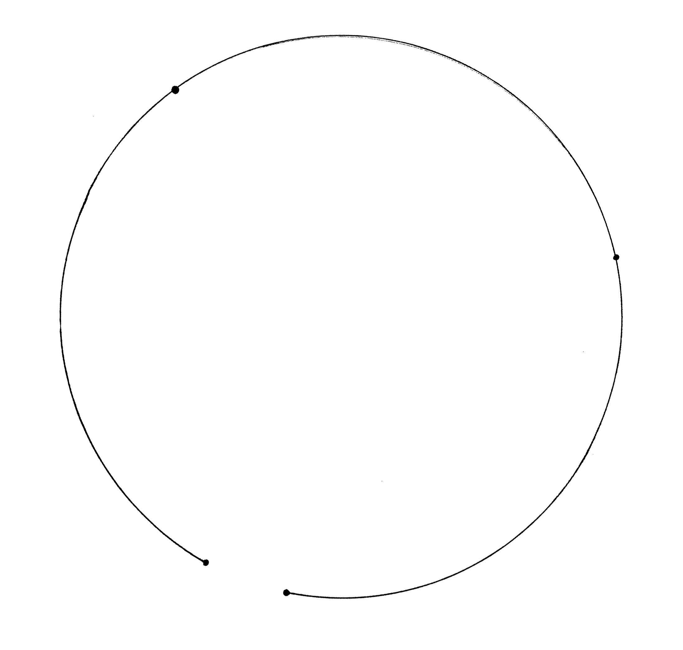
By attaching a marker to different positions on the robot, various size circles can be created using wheel motions A or B as described on page three. For wheel motion C-both wheels moving forward, a string can be attached to the robot under the front slipcover. A large circle can be created with a radius equal to the length of the string. This could be done outside with chalk. It may be helpful to remove the rubber band from the outside wheel to help keep tension on the string. An alternative method is to hold the robot on its side with a reoriented marker or to slide a small piece of pencil lead under the rubber band of one wheel and then hold the robot against a piece of paper as the wheel turns forward.

The diameter of a robot wheel is about 6.7 cm which makes the circumference of the wheel approximately 21 cm. The wheels need about 4.76 revolutions forward for the robot to travel 100 cm. Question number seven is intended to lead students to the equation: circumference equals pi times diameter (C = d).

Questions eight and nine use the area of circle formula: area equals pi times the radius squared (A = r²). Using 3.14 for pi gives a rounded answer of 38.47 cm² for question eight and 4 m for question nine.

A clearly drawn circle about 32 to 40 cm in diameter will be needed for Mission 5.

