Name _____________________________________ Date __________________

Game Spinner Mission 5

What are the chances that you can write your own program on a TI-83 Plus that instructs your robot to spin and randomly land on numbers 1 to 8? If the probability of that is low, can you write the program on the next page without looking at the detailed programming instructions? Try.

YOU NEED:

1 Norland Calculator Robot
1 TI-83 or TI-84 Graphing Calculator
1 Robot Circle from Mission 4
Markers and Colored Pencils

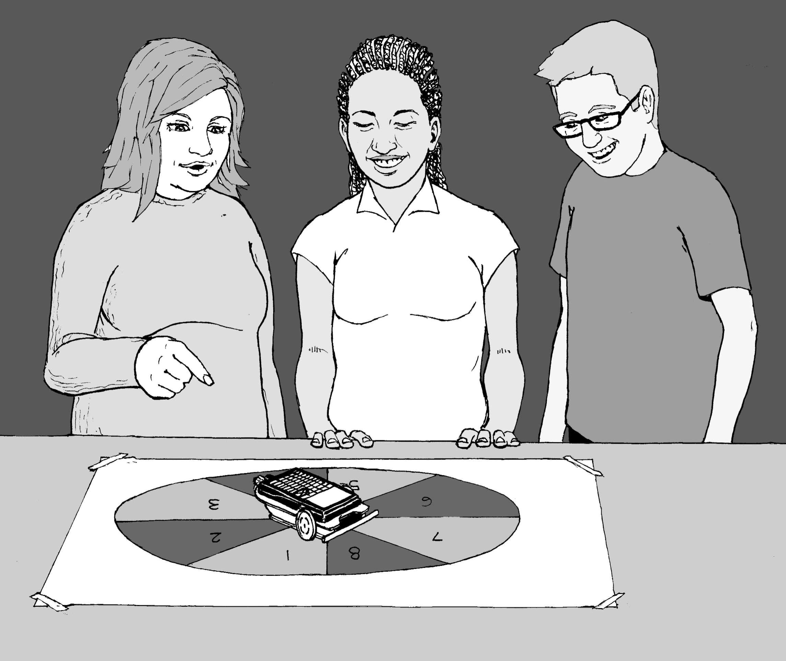
INSTRUCTIONS:

Use a robot drawn 32 to 40 cm circle from mission 4. With a marker divide the circle into eight equal pieces and number 1 to 8 clockwise. Color odd numbered spaces red and the even numbered spaces black. Use your TI-83 Plus to write the program SPINNER (see PROGRAMMING INSTRUCTIONS if needed):
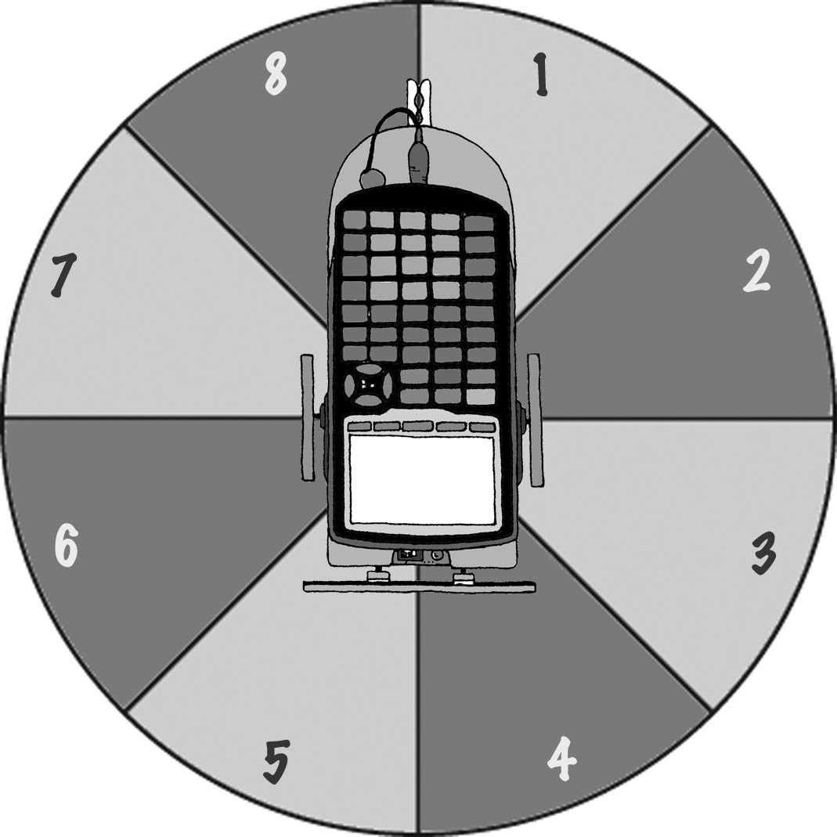
PROGRAM:SPINNER
:randInt(1,8)->X
:Disp X
:If X=1
:Then
:X+209->T
:Disp T
:Send({120,T})
:Get(R)
:Else
:210+(X-1)25->T
:Disp T
:Send({120,T})
:Get(R)
:Stop

This program will randomly pick a number from 1 to 8, display that number, and instruct the robot to spin in one full circle then stop at that number. The clothes peg attached at the back of the robot from the previous exercise makes a good pointer or you can make a cardboard pointer.

The program is designed for the robot to be placed at the center of the spinner with its pivot point (located half way between the two large wheels) directly over the intersection of the four lines used to divide the spinner. The robot's pointer should be set on the line between the 1 and the 8. You may need to adjust the duration of spin times in the program depending on your robot's turn speed or the size of your spinner board.

CHALLENGE:

The Largest Sum Wins!
Odd or red numbers are negative. Even or black numbers are positive. What are your chances of spinning a negative number? Test it out

Use your "robot spinner" to randomly select four numbers. Remember red numbers are negative. Record your numbers and find their sum. You have three trials. Circle your largest sum and write it on the board with your initials. If it's over 10 you get 1 point, if it's over 20 you get 2, over 30 is 3 or -3 for cheating. What are your chances of getting a sum over 30?

Table 1

Spins | Number Value | Spins | Number Value | Spins | Number Value
1 |  | 1 |  | 1
2 |  | 2 |  | 2
3 |  | 3 |  | 3
4 |  | 4 |  | 4
Total

What's Missing?

For Table 2, use your "robot spinner" to randomly select three numbers. Record the numbers, (red, negative and black, positive) and then determine what the fourth number would have to be to arrive at the total given. Again, there are three trials. Have your teacher check your answers. If they are all correct, put +1 by your initials on the board.

Table 2

Spins | Number Value | Spins | Number Value | Spins | Number Value
1 |  | 1 |  | 1
2 |  | 2 |  | 2
3 |  | 3 |  | 3
X= |  | X= |  | X=
Total | 12 |  | -2 |  | 7

Chance and the Parallel Universe

Scientists theorize that there are only so many ways matter can be arranged in our observable universe (about 2 to 10¹¹⁸ arrangements) before things must repeat. They view space as infinite and that probability dictates that you have an exact twin 10 to 10²⁸ meters away from where you are standing right now and that 10 to 10¹¹⁸ meters away is a totally identical parallel universe.


Spin a random number and record it across from spin 1 in Table 3 below. How many more spins would you predict will be required before the number is repeated? Given enough spins, will the number always repeat itself? Test it out and record the numbers randomly selected until your initial number is repeated. Show your teacher your results and the answers to the above questions and he/she will award points accordingly.

Table 3

Spins | Number | Spins | Number | Spins | Number
1 |  | 6 |  | 11
2 |  | 7 |  | 12
3 |  | 8 |  | 13
4 |  | 9 |  | 14
5 |  | 10 |  | 15

RESULTS:
(Answer questions on a separate sheet of paper.)

- What is the theoretical probability of the robot pointing to an even number and then an odd number?

- What are the chances of the robot pointer landing on a prime number?

- In space if you exhaust all possible arrangements of matter, what would happen after that? (Your opinion)

- Do you have an identical twin in another universe? Why or why not?
Extension

Somebody Give Me a Number

Randomly pick four numbers with the robot spinner and using the basic operations (add, subtract, multiply, or divide) make the largest number possible. You have to use all four numbers, but only once, and each operation may only be use once.

Table 4
Spins | Number | Calculations
1
2
3
4
5
 |  | Largest Number:

Spins | Number | Calculations
1
2
3
4
5
 |  | Largest Number:

Game Spinner Mission 5

PROGRAMMING INSTRUCTIONS:
Turn on TI graphing handheld. Press the [PRGM] and arrow to highlight NEW. Press [ENTER], then spell out SPINNER by pressing the appropriate keys. Press the [ENTER] button and you're ready to enter the first command for the program.

Line 1: Press [MATH], then use arrow to highlight PRB. Use the arrow to scroll down to 5: randInt (. Press [ENTER]. Type in 1,8 and close the parentheses by pressing ). Press [STO]. Press the key that has symbols on it (x,t,theta,pi) and [ENTER]. The first line should appear as:
:randInt(1,8)->X

Line 2: Press [PRGM], then use the arrow key to highlight I/O. Arrow down to 3: Disp, and press [ENTER]. Press (x,t,theta,pi) and [ENTER]. The second line should appear as:
:Disp X

Line 3: Press [PRGM] and CTL will be highlighted as well as 1: If. Press [ENTER]. Press the key that has symbols on it (x,t,theta,pi). Press [2ND] and [MATH] and TEST will be highlighted as well as 1: =. Press [ENTER] and then type the number 1 followed by [ENTER] again. The third line should appear as:
:If X=1

Line 4: Press [PRGM] and CTL will be highlighted. Arrow down to 2: Then. Press [ENTER] twice. The fourth line should appear as:
:Then

Line 5: Press (x,t,theta,pi). Press the + (addition) key and then type in 209. Press [STO]. Press [ALPHA] T. Press [ENTER]. The fifth line should appear as:
:X+209->T

Line 6: Press [PRGM], then use the arrow key to highlight I/O. Arrow down to 3: Disp, and press [ENTER]. Press [ALPHA] T. Press [ENTER]. The sixth line should appear as:
:Disp T

Line 7: Press [PRGM], then use the arrow key to highlight I/O. Arrow down to B: Send ( and press [ENTER]. Press [2ND] and { (the ( key) for an open brace. Type in 120, (including the comma). Press [ALPHA] T. Close the braces and parentheses by pressing [2ND] }, and then ). Press [ENTER]. The seventh line should appear as:
:Send({120,T})

Line 8: Press [PRGM], then arrow to highlight I/O. Arrow down to A: Get (. Press [ENTER]. Press [ALPHA] R, press ) then [ENTER]. The eighth line should appear as:
:Get(R)

Line 9: Press [PRGM] and CTL will be highlighted. Arrow down to 3: Else. Press [ENTER] twice. The ninth line should appear as:
:Else

Line 10: Type in the number 210 then press the + (addition) key. Press (, then press (x,t,theta,pi). Press the - (subtraction) key, then type 1. Press ) and then type 25. Press [STO]. Press [ALPHA] T. Press [ENTER]. The tenth line should appear as:
:210+(X-1)25->T

For lines 11 through 13, repeat lines 6 to 8, that is:
:Disp T
:Send({120,T})
:Get(R)

Line 14: Press [PRGM] and CTL will be highlighted. Arrow down to F: Stop. Press [ENTER]. The fourth line should appear as:
:Stop

Press [2ND], then QUIT (the [MODE] key).

Teacher Notes

Game Spinner Mission 5

ACTIVITY NOTES:

The parallel universe information is based on the article Parallel Universes by Max Tegmark in the May 2003 Scientific American magazine, page 40.

Award points as you see fit for the Table 3 activity. At the end of the activity, one way to reward the top individuals or teams with the highest total, is allow them to pick a prize box. Three mystery prize boxes can be made ahead of time, one with 2-3 candy bars, one with a candy bar, and a dud prize. After the game show Let's Make a Deal, the teacher can offer to "buy" a box back after it has been chosen for a sure candy bar. Probability can be discussed as each box is chosen.

Question one and two treat the numbers on the spinner board as being all positives. The answer to number one is 1/4 and the answer to number two is 1/2. Many other types of probability questions can be asked such as, asking for the probability of landing on a multiple of 2 or 3, a perfect square, etc.

