Name _____________________________________ Date __________________

Game Day! Mission 6

Congratulations! You've made it to Game Day! If you've sneaked ahead and skipped the previous lessons you won't have a clue how to program your robot to do these activities. Go back to Mission 1 and start over. If you've completed the previous five missions, Great Job! You're ready to start.

YOU NEED:

1 Norland Calculator Robot
1 TI-83 or TI-84 Graphing Calculator
And a bunch of stuff depending which games you play

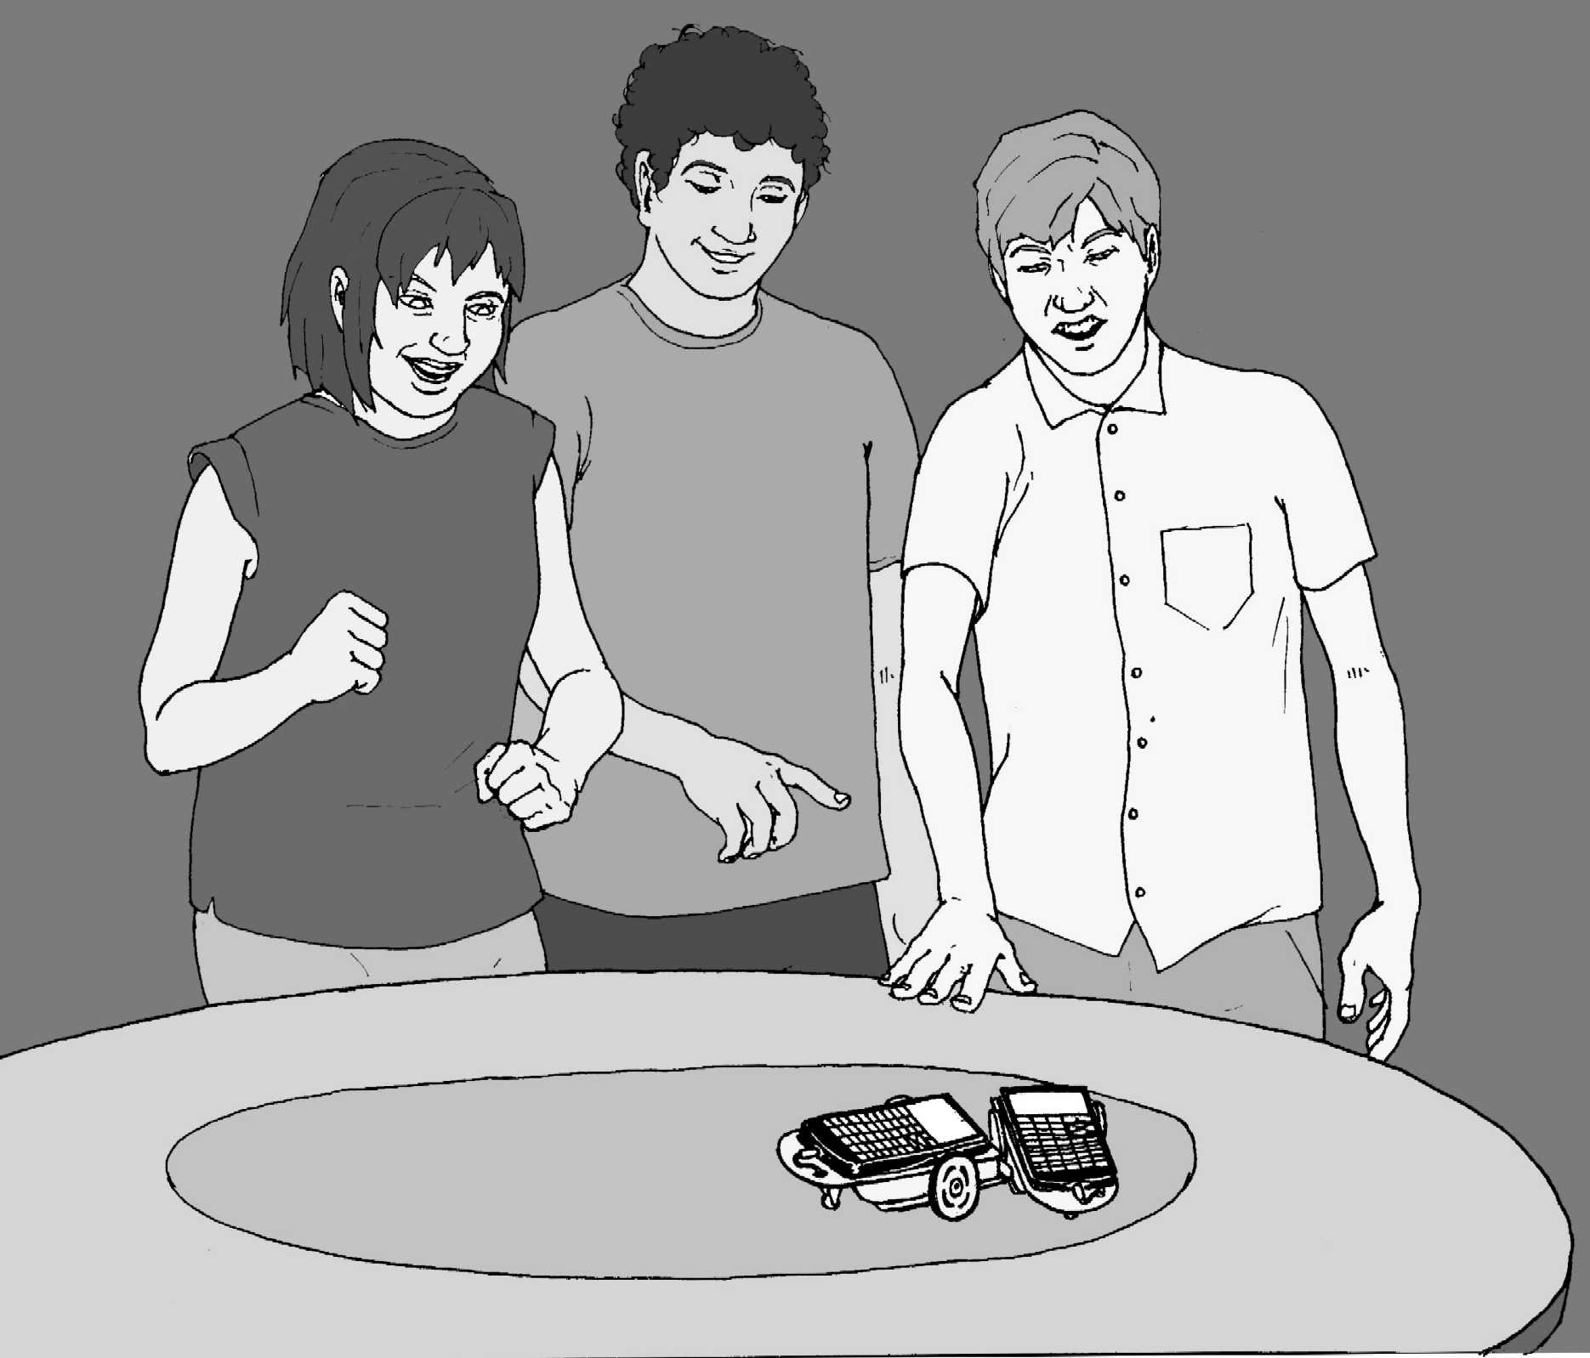

INSTRUCTIONS:

Your teacher will divide you into groups and show you which game to start with. Each group will have a chance to play all six games.

GAMES

- KING OF THE RING On a large table use tape to lay out a circular ring approximately one meter in diameter. If appropriate, cover the ring with graphite to reduce friction and remove rubber bands from the robots' wheels.

Place two robots with bumpers facing each other at the center of the ring, about 40-cm apart. Start the contest. The first robot to push any two wheels (back roller included) of his opponent's robot out of the ring WINS!

- ROBOT RACE Use the Game1 program on the last page which will randomly cause good and bad things to happen to your robot's forward progress. Start a number of robots three meters away from a wall and see which robot reaches the wall first. Switch the game around and make the last robot to arrive the winner.

Separate into two groups on either side of a room with robots facing each other. All start at "GO". The group who has the most robots reach the opposing team's wall WINS!

- ROBOT BOWLING Setup ten markers in a triangular shape, one meter away from the robot. Program the robot to knock them down. For more of a challenge, have the robot hit a ball and knock the "pins" down.

- ROBOT JOUSTING With straws and paper, fashion a jousting lance for each robot. Also make a straw flag that sets on the front of the robot and is attached by a piece of clay.

Two robots face each other about one meter away, then charge! The first robot to knock its opponent's flag off WINS!

- TOPPLE THE IMPERIAL WALKER Obtain a Moon Walker or similar robot. Start your robot one-meter away from the Moon Walker. Start the Moon Walker. The object is to charge after the Moon Walker and topple it in the shortest possible time.

- RELAY RACE This is a four meter relay race. Instead of passing a baton, robots tag their partners' bumpers. Use four robots per team, place them one meter apart with the finish line one-meter away from the last robot. After the first robot is started, no other robots may be touched. The remaining robots must all be activated by another robot hitting (tagging) their bumpers. The first team to get their fourth robot across the finish line WINS!

RESULTS

How Did You Do?

Team Members | King of the Ring | Race | Bowling | Jousting | Topple | Relay
Game Day Mission 6

PROGRAMMING:

PROGRAM:GAME1
:Lbl A
:randInt(1,10)->X

:Disp X
:If X=3
:Then
:Disp "WAIT"
:Send({111,300})

:Get(R)
:GoTo A
:Else
:If X=5
:Then
:Disp "BACK"
:Send({100,300})

:Get(R)
:GoTo A
:Else
:If X=7
:Then
:Disp "SPIN"
:Send({120,235})

:Get(R)
:Send({102,235})

:Get(R)
:GoTo A
:Else
:Disp "GO"
:X*100->T
:Disp T
:Send({322,T})
:Get(R)
:If R<T
:Then
:Disp "YOU FINIS
H"
:STOP
:END
:GoTo A

Teacher Notes

Game Day! Mission 6

ACTIVITY NOTES:

Moon Walker or similar robot available at: http://www.discountcampus.com/cgi-bin/webc.exe/store/st_prod.html?p_prodid=4553&sid=KI8iw0@gH60DOQ

For the Relay Race the following program might be helpful:

PROGRAM:RELAY
:Send({211})
:Get(R)
:Send({100,50})
:Get(R)
:Send({120,92})
:Get(R)
:Send({222})
:Get(R)

This program is for a robot waiting to be tagged. Start the program and the robot will wait until its bumper is hit, backup, then turn 180º (as always adjust the time of the turn as necessary), and run forwards until it tags the next robot or crosses the finish line. See if students can write a program that cuts time off their run. For instance, the second through fourth robot can simply backup when "tagged." The starting robot in the relay only needs the commands:

PROGRAM:START
:Send({222})
:Get(R)

King of the Ring was the most popular game in my class. Students used strategies of charging, withdrawing, charging again, and turning to knock opponents out of the ring. The Relay Race was also very exciting for the students and graphically demonstrated why scientists test and test again. There are many opportunities for Murphy's Law to sneak into this activity.

