Name _____________________________________ Date __________________

E=mc² Mission 7

In Albert Einstein's famous 1905 equation E=mc², the speed of light, c, in miles per hour, is a very large number. If you square that number, the product is huge. Multiply that times a small amount of mass and the amount of energy produced is hard to imagine. The equation seems as far-fetched as Parallel Universes from Mission 5.

YOU NEED:

6 or more Norland Calculator Robots
6 or more TI-83 or TI-84 Graphing Calculators
1 2-3" Rubber Ball (Neutron)
Program: ATOMSPLT, NEUTRONB, and NEUTRONL

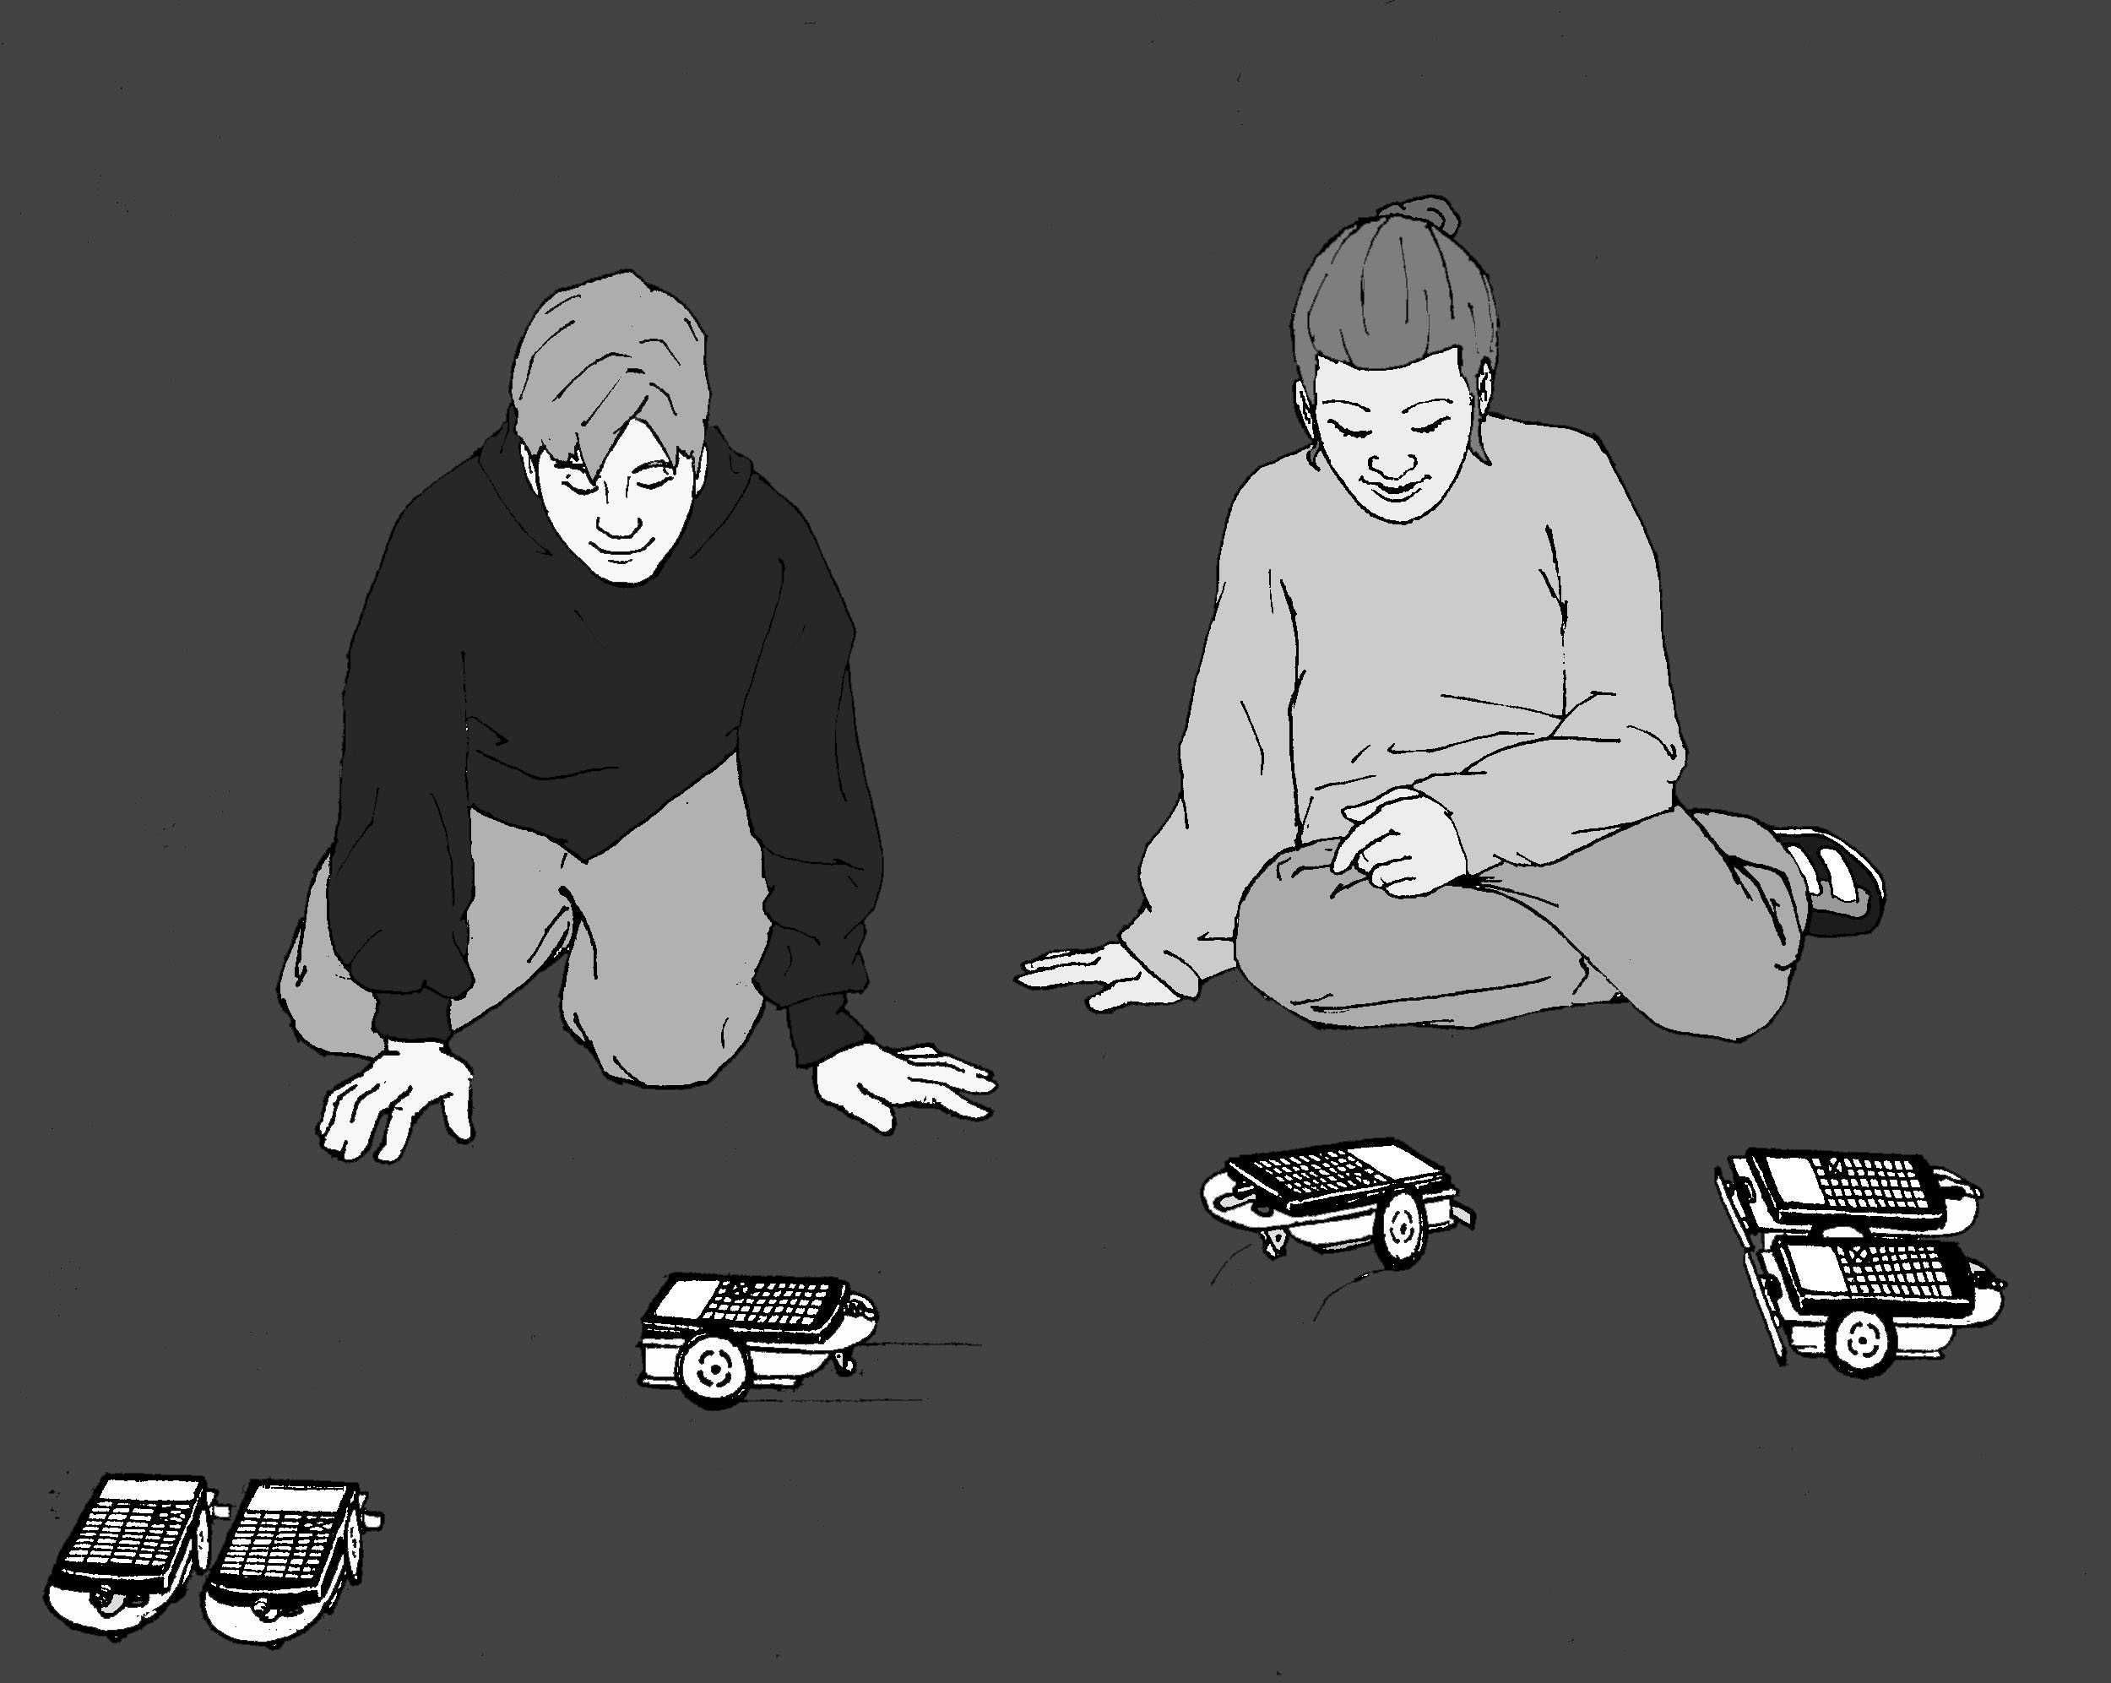
E=mc²

BACKGROUND:

The speed of light is approximately 670,000,000 mph. Use your TI-83+ to calculate what happens to the speed of light when it is "squared." You will get an answer in scientific notation. Write this number in normal notation below.

Think of this as a conversion factor for changing mass into energy. If any mass is pushed back across the = sign and multiplied times the number above, the resulting energy can be enormous.

Because of the power offered by this simple equation and early indication that the equation might actually be true, individuals were ask to go to great lengths for their country and the common good. In efforts to prevent Nazi Germany from developing a nuclear device, a member of the Norwegian underground was asked to kill his fellow countrymen who were aboard a ferry carrying materials need for the German nuclear effort. He did it, ultimately based on the potential of the equation above.

On August 6, 1945 the power of the equation was realized in the atomic bomb dropped on Hiroshima, Japan, by America. Neutrons were sent into the nucleus of an enriched uranium atom splitting it and releasing two neutrons that in turn struck other uranium atoms. In the resulting chain reaction, two became four, four split into 8, and so on until approximately 2⁸⁰ atoms were split. Energy equivalent to 15-20 kilotons of TNT was released and temperatures in excess of a million degrees were produced.

INSTRUCTIONS:

Simulation of Nuclear Fission Chain Reactions

The following program is a progressive doubling program. The numbers, like atoms being split, will double before your eyes from 4 to 8 to 16 to a VERY LARGE number.

PROGRAM:ATOMSPLT
:ClrHome
:0->X
:2->Y
:Input "2*2^X:
",Z
:Z-1->Z
:Lbl A
:Y*2->Y
:X+1->X
:Disp Y
:If X<Z:GoTo A

Start the program and key in 20 (2²⁰) and press [ENTER], try 40, finally key in 80 (2⁸⁰) and press [ENTER]. You will get an answer in scientific notation. Round the decimal to the hundredth place and write this number in normal notation below.

Write the program for a robot chain reaction, NEUTONB or NEUTONL. Half the robots need NEUTRONB and the other half need NEUTRONL. The programs can be written easily by first creating the program names and then recalling the RELAY program from Mission 6.

From the new NEUTONB or NEUTONL program press the yellow [2nd ] key, then RCL (the STO-> key). Press PRGM, then scroll over to EXEC and select RELAY. Press [ENTER] twice and the instructions from RELAY will be added to NEUTONB or NEUTONL. Edit the commands and times as necessary.

PROGRAM:NEUTRONB
:Send({211})
:Get(R)
:Send({100,120})

:Get(R)
:Send({120,82})
:Get(R)
:Send({222})
:Get(R)

In the program NEUTONB, the "B" is for back. After the bumper is hit, the robot backs up, turns around, and then heads the opposite direction until it hits other robots or some other object.

PROGRAM:NEUTRONL
:Send({211})
:Get(R)
:Send({111,70})
:Get(R)
:Send({102,40})
:Get(R)
:Send({222})
:Get(R)

In the program NEUTONL the "L" is for left. After the bumper is hit, the robot pauses, turns 90⁰ left and then moves forward until it hits other robots or some other object.

Make an initial uranium atom by placing an "L" programmed robot to the left and wheel to wheel with a "B" programmed robot. This first pair of robots can be positioned with bumper of the "B" robot touching and slightly behind the bumper of the "L" robot. Both robots will be activated when the bumper of the "L" robot is struck.

Set additional pairs of robots (uranium atoms) about one foot apart with bumpers together and in position to be hit (split) by incoming single robots (neutrons). Add as many pair as you can. In the diagram below TT represents two robots together with bumpers touching and O is the rubber ball ("neutron bullet") coming in to start the chain reaction.

Roll the rubber ball ("neutron bullet") towards the "L" robot in your first robot pair and a chain reaction will start with energy being released as each pair (uranium atom) is split apart. One neutron becomes two, two becomes four and so on. As shown by the equation:

₂₃₅U + 1 neutron -> 2 neutrons + ₉₂Kr +₁₄₂Ba + ENERGY

Different products like ₉₂Kr and ₁₄₂Ba can be produced in this reaction, but are not shown in this simulation.

QUESTIONS:

- Besides atomic weapons, what are some other applications of nuclear fission and E=mc²?

- How does the equation E=mc² apply to the energy being generated by the sun?

- If it were possible to change a one kilogram textbook (mass) completely into energy, it would produce enough electricity to light 47,000 60-watt light bulbs for one year. In metric energy units this equivalent to 90,000,000,000,000,000 joules. Write this number in scientific notation and explain why scientific notation is useful.

"Imagination is more important than knowledge. Knowledge is limited. Imagination encircles the world." - Einstein

- Make up your own famous equation that will change the way we view the universe. Explain the meaning of each part of the equation and how understanding the equation will benefit the world.

Teacher Notes

E=mc² Mission 7

ACTIVITY NOTES:

How to create a spectacular chain reaction demonstration using ping-pong balls can be found at: http://www.ap.stmarys.ca/demos/content/modern/mousetrap_reactor/mousetrap_reactor.html

ThinkQuest's Nuclear Processes home site has links to student level information on this topic: http://library.thinkquest.org/17940/index.html
The links include an excellent interactive visual of nuclear fission as related to a nuclear power plant: http://library.thinkquest.org/17940/texts/java/Reaction.html
Additional information on basic nuclear fission and student questions can be found at: http://library.thinkquest.org/17940/texts/fission/fission.html
More information and student questions about Einstein's equation, E=mc² can be found at: http://library.thinkquest.org/17940/texts/atom2/atom2.html#equ

Book reference: E=mc²: A Biography of the World's Most Famous Equation, by David Bodanis.

In normal notation 670,000,000² equals: 448,900,000,000,000,000.
With the scientific notation decimal rounded to the second places, 2⁸⁰ in normal notation equals: 1,210,000,000,000,000,000,000,000.

In scientific notation 90,000,000,000,000,000 equals 9.0 X 10¹⁶.

Other applications of E=mc² include: nuclear submarines, power for space vehicles, nuclear power plants, smoke detectors with radioactive americium inside, red-glowing emergency exit signs with radioactive tritium inside, some medical diagnostic devices, radiation treatment of cancer, carbon-14 dating, and our sun. See pages 192-194 in Bodanis' book.

The energy produced by the sun makes our planet habitable. This energy is produce by nuclear fusion where hydrogen atoms are combined to make helium. Select fusion at the ThinkQuest site mentioned above for more detailed information.

