Name _____________________________________ Date __________________

Cool Stuff Mission 8

There is more to your robot and TI-83/84 than meets the eye. Alfred and George live inside along with an exploding star. A new DaVinci, Escher, or Picasso may also be discovered.

YOU NEED:

1 Norland Calculator Robot and 1 TI-83 or TI-84 Graphing Calculator
1 Clothes Peg, Marker
Graph Paper
Drawing Paper 18"X24"
Program: SCORPIO

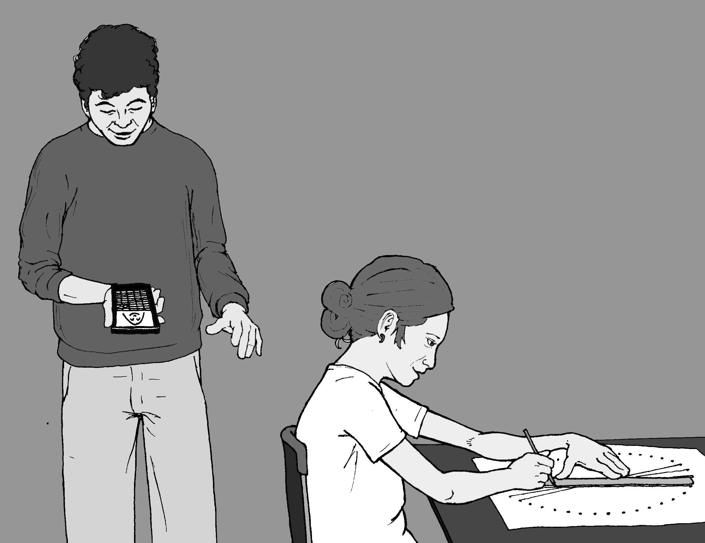

INSTRUCTIONS:

Alfred:

On your TI-83/84 press the [2nd] key and then press [ZOOM] for format. Scroll down with the arrow keys and highlight AxesOff. Press [ENTER].
Press the [Y=] key and enter the following equations:

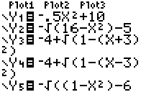

All keys are visible on the face of your graphing calculator. Be sure and distinguish between a negative and a subtraction sign. Don't leave out the ²) at end of equations three and four. Press the[GRAPH] key to see Alfred.

George:

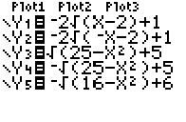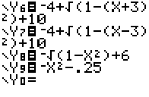Leave the setting as above. Press the [Y=] key and enter the following equations, then press the [GRAPH] key. Meet George.

Explosion:

Leave format setting as above. Press the [2nd] key and then press [ZOOM]. Scroll down with the arrow keys and highlight 5:ZSquare. Press [ENTER]. Press the [MODE] key and then scroll down with the arrow keys and highlight Pol. Press [ENTER]. Press the [Y=] key and enter the following equations, then press the blue [GRAPH] key.

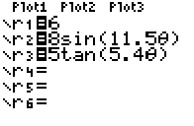

Make Your Own:

Press the [2nd] key and then press [ZOOM]. Scroll down with the arrow keys and highlight 6:ZStandard. Press [ENTER]. Press the [MODE] key and then scroll down with the arrow keys and highlight Func. Press [ENTER]. Press [2nd] key and then press [ZOOM] for format. Scroll down with the arrow keys and highlight AxesOn. Press [ENTER].

Press the [Y=] key, delete any other entries, and then enter the following equations. When finished, press the blue [GRAPH] key and on graph paper draw what happens to the parabola as 3 is added and subtracted. Use different colors to draw the graphs for each equation.

\Y₁=X²
\Y₂=X²+3
\Y₃=X²-3

Insert parentheses around the second and third equations. Instead of squaring just X, square the whole expression. First predict what the graphs will look like, then press the [GRAPH] key and draw what happens to the parabola on graph paper.

\Y₁=X²
\Y₂=(X+3)²
\Y₃=(X-3)²

Graph the following and draw what happens to the parabola:

\Y₁=X²
\Y₂=.5X²
\Y₃=.25X²
\Y₄=-X²

For straight lines, graph and draw the following linear equations:

\Y₁=X
\Y₂=X+3
\Y₃=X-3

Predict what the following absolute value equations will look like, then graph and draw them. (For absolute value, press [MATH], arrow over to NUM, and select number 1. Press [ENTER].

\Y₁=abs(X)
\Y₂=abs(X)+3
\Y₃=abs(X)-3

Try:

\Y₁=abs(X)
\Y₂=abs(X+3)
\Y₃=abs(X-3)

For a circle, press the [2nd] key and then press [ZOOM]. Scroll down with the arrow keys and highlight 5:ZSquare. Press [ENTER]. Graph and draw the following circles and determine their radii and diameters:

\Y₁=(100-x²)
\Y₂=-(100-x²)
\Y₃=(16-x²)
\Y₄=-(16-x²)

CHALLENGE:

Make your own creation on your TI-83/84 using variations of the function equations above. Write down your equations for a partner and see if they can duplicate your design.

Circular Lines

Using the robot, paper, and marker draw a circle with the circumference of approximately 36 inches. This can be accomplished by attaching a marker 5.75 inches from the robots pivot point. On most robots, a marker taped to the back is very close. (If necessary, see Mission 4 for more on robot circle drawing.)

After you've made your circle, put 36 dots evenly spaced (one inch apart) around the circumference. Number the dots from zero to 35. Also, place the number 36 above the zero.

Make a solution table for the equation Y=X+21.

X | 0 | 1 | 2 | 3 | . . .
Y | 21 | 22 | 23 | 24 | . . .

On your "circle graph," use a straight line to connect 0 with 21, 1 with 22, 2 with 23, etc. Extend the solution table to X=36. In order to connect larger numbers, continue the number pattern around the outside of the circle. Your efforts will be rewarded by an intricate symmetrical pattern that can be enhanced by shading it with colored pencils.

The Robot Does the Work

Write the following program. Place your robot on a large sheet of paper with a marker on the back and have it ready to draw. Start the program. Hit the bumper to stop the robot when you're satisfied with your design.
:Send({320,10})
:Get (R)
:If R<10:Goto B
:Goto A
:Lbl B
PROGRAM:SCORPIO
:Lbl A
:Send({321,10})
:Get (R)
:If R<10:Goto B
Teacher Notes

Cool Stuff Mission 8

ACTIVITY NOTES:

Alfred:
The activity provides a fun way to explore functions and an opportunity to extend concepts while encouraging artistic design.



George:



Explosion:

