Name _____________________________________ Date __________________

Mission to Mars Mission 9

Your robot has been selected for the next mission to Mars. All initial robot movements after landing have to be pre-programmed. After that, if you've successfully completed all previous missions, you're now ready to take full direct control of your robot to explore Mars.

YOU NEED:

1 Norland Calculator Robot and 1 TI-83 or TI-84 Graphing Calculator
1 Submini Coupler (3/32”-RadioShack 274-896)
1 84-inch Data Cable
1 Imagination
Program: EXPLORE or EXPLORE2

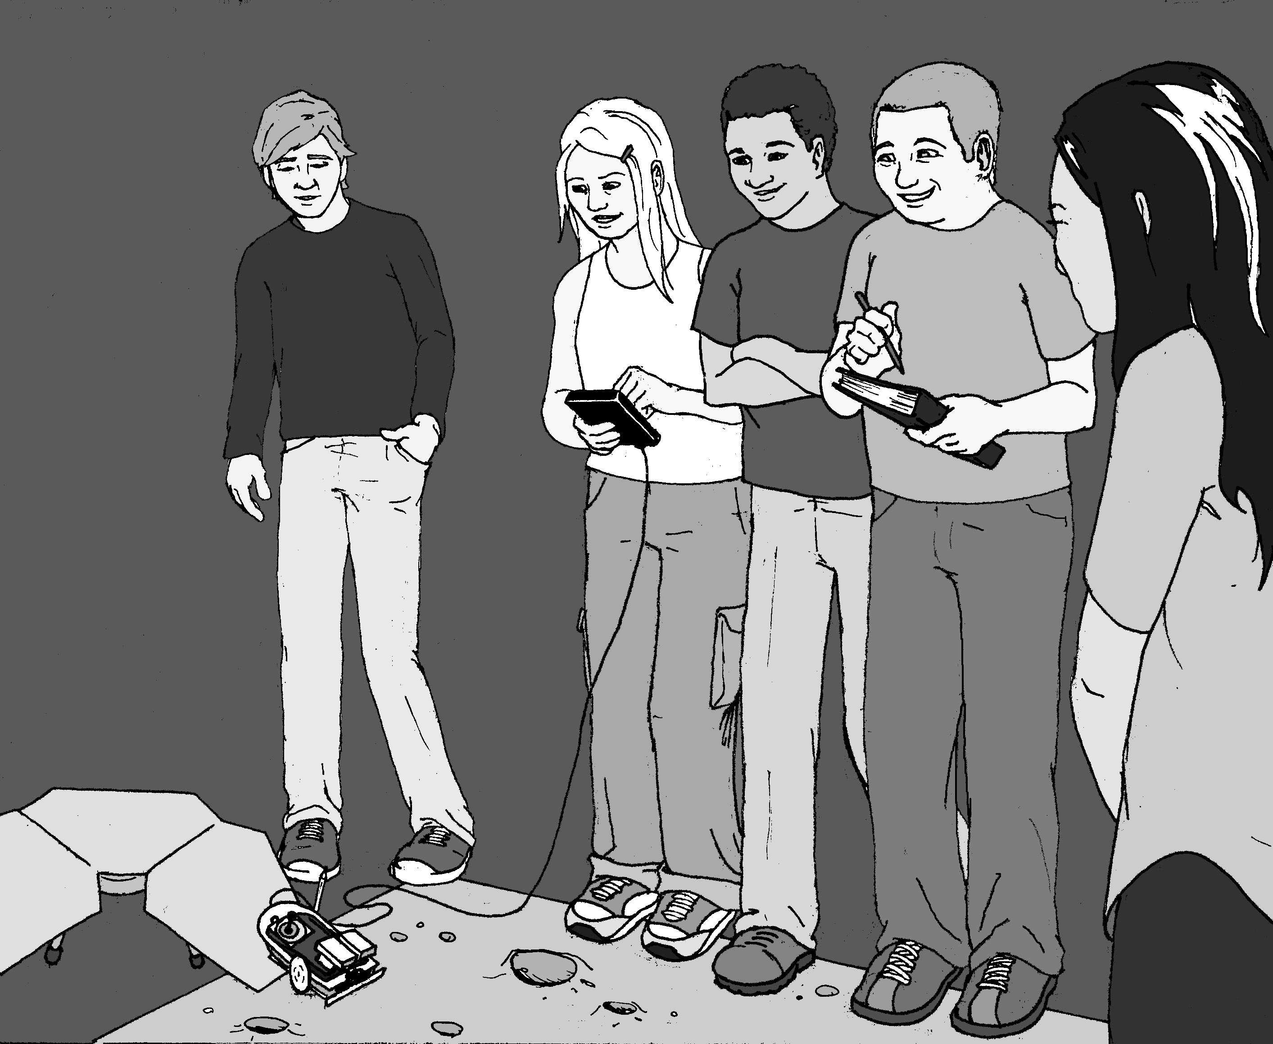
INSTRUCTIONS:

Upon landing, your robot needs to be pre-programmed to drive off the Mars landing vehicle and layout a two meter long transect line. At the end of the line the robot needs to trace out the perimeter of a one meter square rock sampling area. Place a marker at each corner of this sample area.

You are now ready to convert your robot to explorer mode. You have your choice of two programs. EXPLORE below uses the arrow keys on the TI-83/84 and allows remote wire-control of four motions: forward, backward, left, and right. EXPLORE2 (last page) uses the number pad and controls nine different motions.
Write one of the two programs with your TI-83/84 calculator.

Program:EXPLORE
ClrHome
Lb1 A
getKey->X
If X=24: Goto 2
If X=25: Goto 1
If X=26: Goto 3
If X=34: Goto 4
If X=105: Goto 5

Goto A
Lb1 1
ClrHome
Output (4,5, "FOR
EWARD")
Send ({122,100})

Get (R)
Goto A
Lbl 2
ClrHome
Output (4,7, "LEF
T")
Send ({102,42})
Get (R)
Goto A
Lbl 3
ClrHome
Output (4,6, "RIG
HT")
Send ({120,42})
Get (R)
Goto A
Lbl 4
ClrHome
Output (4,5, "BAC
KWARD")
Send ({100,100})

Get (R)
Goto A
Lbl 5
Stop

Remove the TI-83/84 from the robot. Use the submini coupler to connect the 84 inch data cable to the cable coming from the robot. Connect your TI-83/84 to the other end of the 84 inch data cable. To move forward press the up arrow (or [8] key for EXPLORE2). To repeat a movement, simply press the key again. To end either program press [ENTER]. Practice driving and maneuvering your Mars robot rover.

Add simulated equipment and sensors to the top of your robot: high gain antenna, solar array, sundial, instrument deployment device, low gain antenna, pancam, etc. Attach a Velcro strip to the front of the robot for retrieving Mars rocks.

CHALLENGE:

Mars is millions of miles away and even at the speed of light a command from Earth takes several minutes to reach the Mars Rovers. Likewise, to learn the results of a command takes several minutes.

Your teacher will place rocks in the Mars rock sample area and you will need to avoid obstacles and retrieve rock samples without looking. (Mission controllers on Earth can’t instantly “see” the reaction of the Mars Rover when they give a command.) Have a partner direct you where to navigate your robot. Return the rock samples to the Mars landing vehicle. Rocks that are the furthest away are worth more points. Record your results below.

Mission Data:

Trails | Points for Rocks Recovered
A
B
C
Total
Average

QUESTIONS:

- The Spirit and Opportunity Mars rovers have six wheels. What are the advantages and disadvantages of this configuration compared to your robot?

- When the Spirit rover first disembarked off of the Mars Lander, it traveled 3 meters in 78 seconds. Compare this speed to the speed of your robot in meters per second.

- The satellite, Voyager I, is beyond our solar system. When it was 7.555 X 10⁹ miles away from Earth, how long did it take for a signal to reach Voyager and an acknowledgement signal to be received back on Earth? Answer in hours and use 186,000 miles per second as the speed of light.

Teacher Notes

Mission to Mars Mission 9

ACTIVITY NOTES:

You'll need to have some students make a cardboard Mars landing vehicle and some fuzzy "rock" that can be picked up by Velcro. There's plenty of information about Mars exploration on the Internet. At this writing, the Mars rovers, Spirit and Opportunity, are safely on Mars poised to make new discovers. The answer to question 3 is approximately 22.57 hours.

Program: EXPLORE2
ClrHome
Lb1 A
getKey->X
If X=73: Goto 1
If X=93: Goto 2
If X=82: Goto 3
If X=84: Goto 4
If X=74: Goto 5
If X=94: Goto 6
If X=72: Goto 7
If X=92: Goto 8
If X=83: Goto 9
If X=105:Goto 1
0
Goto A
Lb1 1
ClrHome
Output (4,5, "FOR
EWARD")
Send ({122,99})
Get (R)
Goto A
Lbl 3
ClrHome
Output (4,7, "LEF
T")
Send ({102,43})
Get (R)
Goto A
Lbl 4
ClrHome
Output (4,6, "RIG
HT")
Send ({120,42})
Get (R)
Goto A
Lbl 2

ClrHome
Output (4,5, "BAC
KWARD")
Send ({100,99})
Get (R)
Goto A
Lbl 5
ClrHome
Output (4,5, "FOR
RIGHT")
Send ({120,22})
Get (R)
Goto A
Lbl 6
ClrHome
Output (4,4, "BAC
KRIGHT")
Send ({120,67})
Get (R)
Goto A
Lbl 7
ClrHome
Output (4,5, "FOR
LEFT")
Send ({102,22})
Get (R)
Goto A
Lbl 8
ClrHome
Output (4,5, "BAC
KLEFT")
Send ({102,67})
Get (R)
Goto A
Lbl 9
ClrHome
Output (4,6, "DEF
ENCE")
Send ({120,99})
Get (R)
Send ({102,99})
Get (R)
Goto A
Lbl 10
Stop

For the CHALLENGE activity two 84-inch cables connected together are useful for extended range. The 84-inch data cable (7.5 foot CBR I/O cable) can be found at:

http://epsstore.ti.com/OA_HTML/ibeCCtpItmDspRte.jsp?section=10413&item=21896&JServSessionIdrootdlek21=5c94hnrq41.n6LzoN8L/AzOnMTOogTxpQOUn6LzoN8L/AzOnMTOogTxpQOUahmKa30-

